




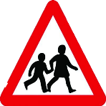
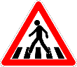
1
Road Safety in Northumberland

Name
School Name
Date

Road Safety Progress Form
 | Answers Before Activity | Answers After Activity
Write out the 4 Green Cross Code steps. | S  L  L  T | S  L  L  T
How far away from the kerb should you stand? (cm)
When crossing the road, what direction should you look first?
When you cross the road do you walk or run?
Should you walk straight across the road or cross diagonally?
What 4 things should you do before you step on a zebra crossing, pass a driveway or when the green man comes on?
Score

